CHING Francois Henri – 7001915

3D Game Basis

Final Term - Turn Around

Personal report

In this document, you will find the tasks I have completed during the game development of the final term, the assets I used and my personal comments and regrets about the project.

1. **My tasks**
2. Main menu

The main menu (which also acts as a welcome page) has 3 buttons:

* A Play button, which leads to the level selection menu
* A Settings button, to manage the volume, the resolution of the game and the graphic quality
* A Quit button, to exit the game

1. Settings menu

The settings menu allows you:

* To adjust the volume
* To change the game resolution
* To (not) set the game in full screen
* To change the graphic quality of the game

1. Level Selection

In the level selection menu, the player can either choose the level he wants to play or go back to the main menu.

1. Pause menu

You can get to the pause menu by pressing the escape key.  
In the pause menu, you can:

* Resume the game
* Go to the settings menu
* Go back to the menu
* Exit the game

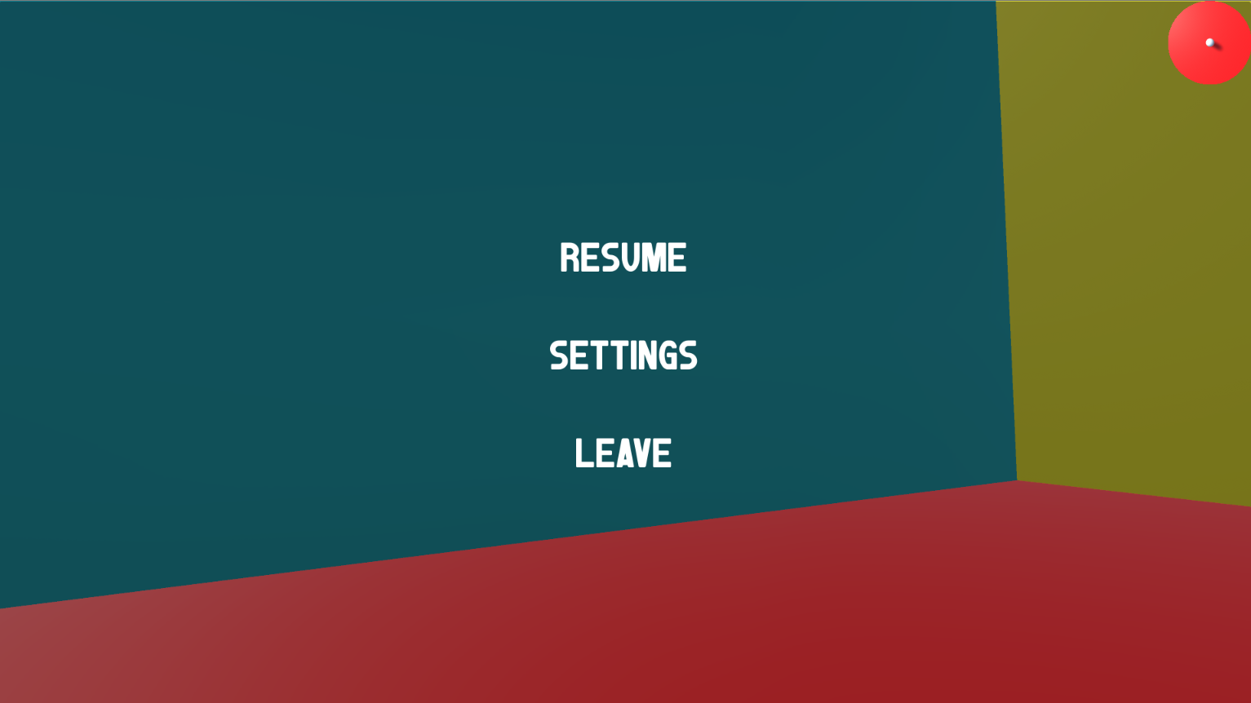

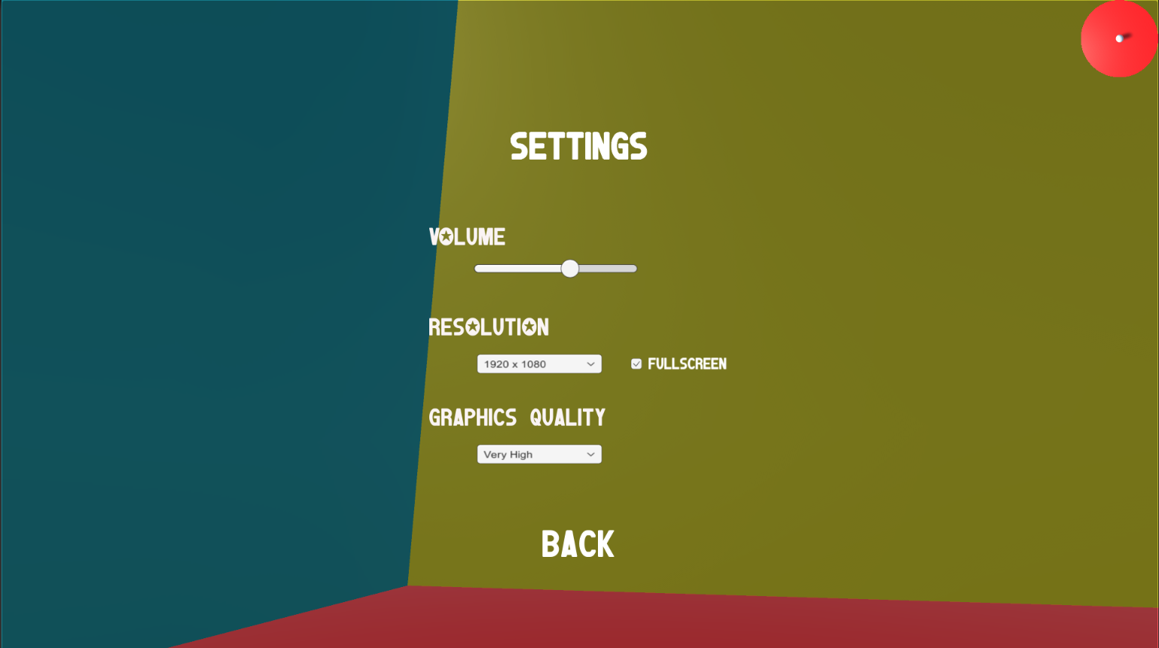

1. Win menu

The win menu is a simple menu where it shows to the player he won the game and where he can go back to the menu or close the game.

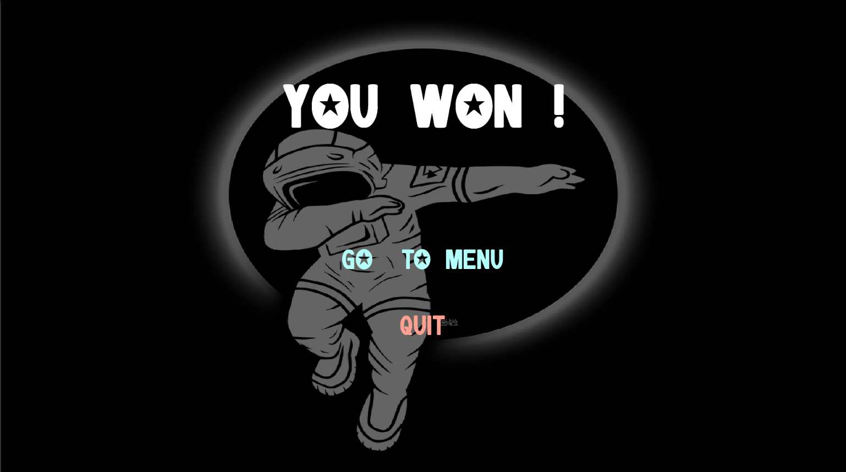

1. Mini map of the game

The mini map of the game (at the top right of the screen) allows the player to track his position in the map from a top-down view by using a camera following the player’s movements.

1. **The assets**

The assets I have used for the project:

* Main menu background: <https://kalspriggs.files.wordpress.com/2013/10/original.jpg>
* Win menu background: <https://cdn.dribbble.com/users/4242369/screenshots/7883254/11_4x.jpg>
* Mini map image: I used the image we used in class 9

1. **Personal comments and regrets**

My biggest regret is that I think that with more time, we probably would have been able to make an extremely fun game.